Er RAJAT KALIA
(B.TECH IIT-Delhi)
PH. 9815439805
Er MANISH KALIA
B.TECH (Delhi COLLEGE OF ENGINEERING)
PH. 09990074601,9878146388

9DE

FUNCTION & GRAPH
Functions:
Let A B be two non empty sets & F is a relation which associates each elemenet of set A with unique element of set B, then F is c/d a function from A to B.
Set A is called domain of F & B be the co domain of F.
Set of elements of B, which are images of elements of set A is c/d range of F.
F : A B ("F is function of A into B")
If a A then element in B which is assigned to 'a' is called image of 'a' & denoted by F(a).
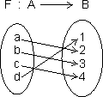
let A = {a, b, c, d}, B = {1, 2, 3, 4, 5}
So, F(a) = 2, F(b) = 3, F(c) = 5, F(d) = 1
Dumb Question: What is non empty set ?
Ans: A set which contain at least one element
eg. A = {1, 2} is non empty set but B = { } is empty set.
No. of Function (or Mapping) From A to B:
Let A = {x₁, x₂, x₃, .......... , x_{m}} F : A B
& B ={y₁, y₂, y₃, .......... , y_{n}}
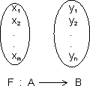
Then if each element in set A has n images in set B.
Thus, total no. of functions from A to B = n^{m}
Dumb Question: How total no. of function from A to B = n^{m} ?
Ans: x₁, element in set A take n images
x₂ element in set A take n images
.............................................
.............................................
x_{m} can take n images.
Total no. of function from A to B
n x n x ............... m times = n^{m}
Domain: Domain of y = f(x) is set all real x for which f(x) is defined (real).
How to find Domain:
(i) Expression under even root (i.e. square root, 4th root) 0
(ii) Denominator 0
(iii) If domain of y = (x) & y = y(x) are D₁ & D₂ respectively then domain of f(x) ± y(x) of f(x).g(x) is D₁ D₂.
(iv) Domain of 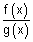is D₁ D₂ - {g(x) = 0}.
Illustration: Find domain of single valued function y = f(x) given by eq. 10^{x} + 10^{y} = 10.
Ans: 10^{x} + 10^{y} = 10 10^{y} = 10 - 10^{x}
y = log₁₀(10 - 10^{x}) {a^{m} = b m = log_{a}b}
Now, 10 - 10^{n} > 0
10¹ > 10^{x} 1 > x
domain x (- , 1)
Dumb Question: What is single value Function ?
Ans. For every point of domains, these is unique image only.
Range: Range of y = f(x) is collection of all output & {F(x)} corresponding to each real no. is domain.
How to find range:
First of all final domain of y = f(x)
(i) If domain Finite no. of points range set of corresponding f(x)values.
(ii) If domain R or R - {some finite points}
Then express x in terms of y. From this find y for x to be defined. (i.e. find values of y for which x exists)
(iii) If domain a finite interval, find least and greatest value for range using mono tonicity.
Illustration: Find range of function y = log_{e}(3x² - 4x + 5).
Ans: y is defined if 3x² - 4x + 5 > 0
[Dumb Question: Why 3x² - 4x + 5 > 0 ?
Ans: ln x is defined only if x > 0]
if x is 0 ln x = - & for - ve x
ln is not defined,
D = 16 - 4 x 3 x 5 = - 44 < 0
& coeff. of x² = 3 > 0
3x² - 4x + 5 > 0 v x R
domain R
y = log_{e}(3x² - 4x + 5) 3x² - 4x + 5 = e^{y}
3x² - 4x + (5 - e^{y}) = 0
Since x is real, So, D 0
(- 4)² - 4(3)(5 - e^{y}) > 0 e^{y} >
y log
range [log, )
CLASSIFICATION OF FUNCTIONS
1. Constant Function: If range of function f consists of only one no. then f is c/d constant function.
Range = { a }
domain x R
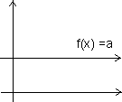
2. Polynomial function: A function y = f(x) = a₀x^{n} + a₁x^{n-} + ...... + a_{n} where a₀, a₁, ....... a_{n} are real constants & n is non -ve integer, then f(x) is c/d polynomial function. If a₀ = 0, then n is degree of polynomial function.
Graph of f(x) = x²
f(x) = x² is called square function. Domain R
Range R⁺ {0} or [0, ]
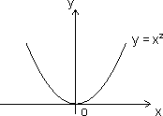
Graph of f(x) = x³:
f(x) = x² is cube function
domain R
Range R
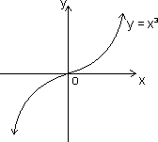
(3) Rational Function: It is ratio of two polynomials
Let P(x) = a₀x^{n} + a₁x^{n - 1} + .......... + a_{n}
Q(x) = b₀x^{m} + b₁x^{m - 1} + .......... + b_{m}
Then f(x) = is a rational function if Q(x) 0
Domain R {x | Q(x) = 0}
i.e. Domain R except those points for which denomiator = 0
Graph of f(x) =
f(x) = is called reciprocal function with coordinate axis as asymptotes.
Domain R - {0}
Range R - {0}
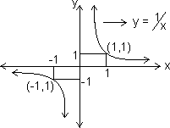
Graph of f(x) =
f(x) =
Domain R - {0}
Range (0, )
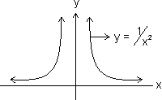
Dumb Question: For y = , how domain & range is R - {0} ?
Ans: For domains
f(x) = + & f(x) = -
So, f(x) is not defined at x = 0
Similarly for Range
as x ± f(x) 0
But we exclude ±
So, Range R - {0}
(4) Irrational Function: Algebraic function containing terms having non-integral rational powers of x are c/d irrational functions.
Graph of f(x) =
f(x) = Domain R⁺ {0} or {0, )
Range R⁺ {0} of [0, )
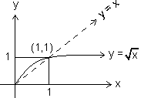
Grafh of f(x) =
f(x) =
domains R
Range R
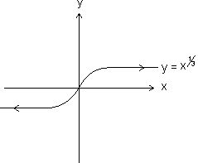
(5) Identity Function: The function y = f(x) = x for all x R c/d identity function on R
Domain R
Range R
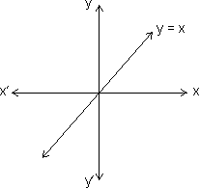

Absolute Value of Modulus Function:
y = |x| = 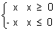
Domain R Range (0, )
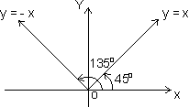
Properties of modulus function:
(i) |x| a - a x a (a 0)
(ii) |x| a x - a or x a (a )
(iii) |x + y| |x| + |y|
(iv) |x + y|
Illustration: Find domain of y = 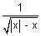
Ans: y is defined if (|x| - x) > 0
|x| > x which hold for -ve x only
Hence domain (- , 0)
(7) Signum Function:
y = Sgn(x) = 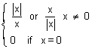
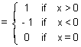
Domain x R
Range {- 1, 0, 1}
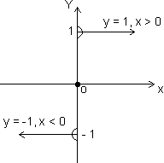
(8) Greatest integer function:
[x] indicates integral part of x which is nearest & smaller integer to x. It is also c/d floor of x or stepwise function.
[2.3] = 2 [5] = 5, [- 0.6] = - 1
In general
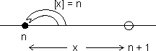
n n < n + 1 (n Integer)
[n] = n
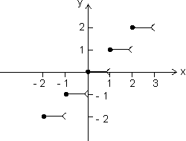

x | [x]
0 x < 1  1 x < 2  2 x < 3  - 1 x < 0  - 2 x < - 1 | 0  1  2  - 1  - 2
Properties of greatest integer function:
(i) [x] = x holds if x I I Integer.
(ii) [x + I] = [x] + I if I is integer.
(iii) [x + y] [x] + [y]
(iv) If [(x)] I, then (x) I.
(v) If [(x)] I, then (x) < I + 1
(vi) If [x] > n x n + 1, n I.
(vii) [- x] = - [x] if x I
& [- x] = - [x] - 1 if x I.
(viii) [x + y] = [x] + [x + y - [x]] for all x, y R.
(ix) [x] + 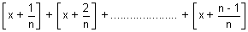
= [n x], n N N natural no.
Illustration: y = 2[x] + 3 & y = 3[x - 2] + 5 then find value of [x + y].
Ans: 2[x] + 3 = 3[x - 2] + 5
2[x] + 3 = 3[x] - 6 + 5 [x] = 4
4 < 5
x = 4 + f (f fraction)
y = 2[x] + 3 = 11
[x + y] = [4 + f + 11] = [15 + f] = 15
(9) Fractional part function:
y = {x}
Let x = I + f, I = [x] & f = {x}
y = {x} = x - [x]
x | {x}
0 x < 1  1 x < 2  2 x < 3  - 1 x < 0  - 2 x < - 1 | x  x - 1  x - 2  x + 1  x + 2
Domain x R
Range (0, 1)
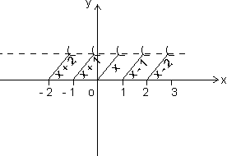
Properties of fraction part of x
(i) {x} = x if 0 < 1
(ii) {x} = 0 if x I
(iii) {- x} = 1 - {x} if x I
Illustration: Prove that [x] + [y] [x + y] where x = [x] + {x}
Ans: x + y = [x] + {x} + [y] + {y}
[x + y] = [[x] + [y] + {x} + {y}]
= [x] + [y] + [{x} + {y}] [By [x + I] = [x] + I]
[x + y] [x] + [y]
(10) Exponential Function:
f(x) = a^{x}, a > 0, a 1
Domain R
Range (0, )
Case I: a > 1
f(x) = a^{x} increase with increase in x.
i.e. f(x) is increasing function ob R
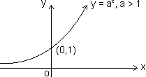
Case II: 0 < a < 1
f(x) = a^{x} decrease with increase in x
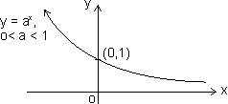
Dumb Question: How range comes out (0, ) ?
Ans: y = a^{x}
Let a > 1
As x
Since a > 1
So, a^{x}
and when x -
a^{x} 0
range (0, )
Logorithmic function:
f(x) = log_{a}x (x, a > 0) & a 1
Domain (0, )
Range R
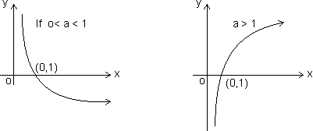
Properties:
(i) Log_{a}a = 1 (ii) log_{b}m a = log_{b}a {a, b > 0, b 1 m R}
(iii) log_{a}b = 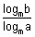 {a, b > 0, a, b 1 & m > 1}
(iv) {a, m > 0 & a 1}
(v) {a, b, c > 0 & c 1}
(vi) log_{m}a < b 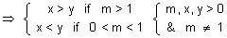
(vii) log_{m}a < b 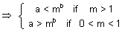
Dumb Question: Why b 1 in log_{b}a ?
Ans: log_{b}a = c b^{c} = a
if b = 1
1^{c} a
Now whatever value of c, 1^{c} a, so, b 1
Illustration: Find domain of f(x) = log₁₀(1 + x³)
Ans: f(x) = log₁₀(1 + x³) exists if
1 + x³ > 0
(1 + x)(1 - x + x²) > 0
But 1 - x² + x² > 0 as D < 0 & a > 0
So, 1 + x > 0
x > - 1
x (- 1, )
Trignometric Function:
(1) Sine Function:
f(x) = sinx
Domain R
Range [-1, 1]
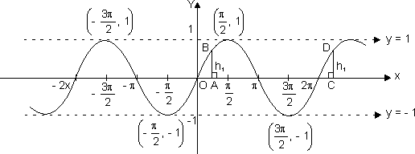
(2) Cosione Function:
f(x) = cos x
Domain R
Range [-1, 1]
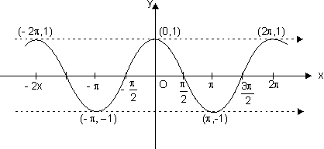

(3) Tangent Function:
f(x) = tan x
Domain R - {(2n + 1) }
Range R
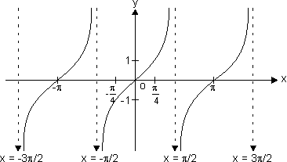
y = tan x increases strictly from - to as x increases from - to , to
x = ± , ± , .......... are asymptotes to y = tan x.
Dumb Question: What is asymptotes ?
Ans: A curve which is tangent to given curve at infinity.
(d) Coecant function:
f(x) = cosec x
Domain R - {n | n I}
Range R - (- 1, 1)
n = n n I is asymptote to y = cosec x
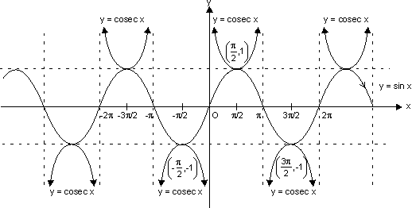
(e) Secant Function:
f(x) = sec x
Domain R - {(2n + 1) | n I}
Range R - (- 1, 1)
x = (2n + 1), n I are asymptote to y = sec x.
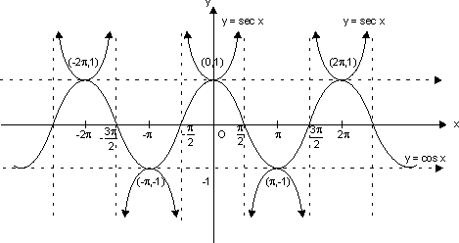
(f) Cotangent Function:
f(x) = cot x
Domain R - {n | n I}
Range R
It has x = n n I as asymptotes.
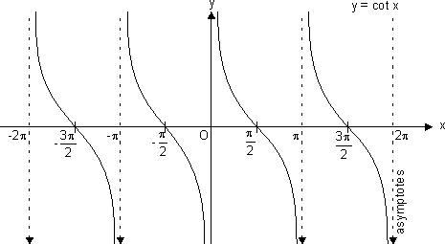
Inverse Function:
(i) Graph of y = sin⁻¹ x;
where
x [-1, 1]
and y 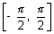
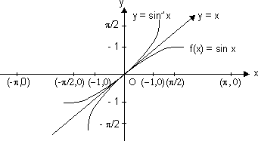
As the graph of f⁻¹ is mirror image of f(x) about y = x.
(ii) Graph of y = tan⁻¹x;
Here,
Domain [-1, 1]
Range [0, ]
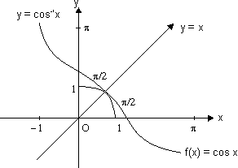
(iii) Graph of y = tan⁻¹x;
Here ,
Domain R
Range .
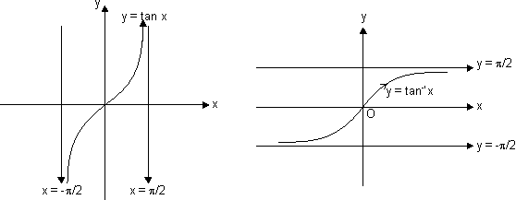
(iv) Graph of y = cot⁻¹x;
We know that the function f:(0, ) R, given by f() = cot is invertible.
Thus, domain of cot⁻¹x R and Range (0, ).
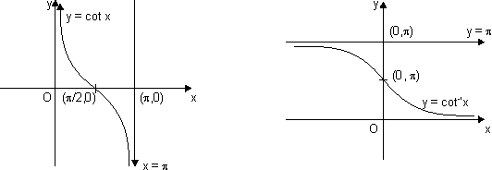
(v) Graph for y = sec⁻¹x;
The function f : [0, ] - (- , - 1) [1, ] given by f() = sec is invertible.
y = sec⁻¹x, has domain R - (- 1, 1) and range [0, ] - : shown as
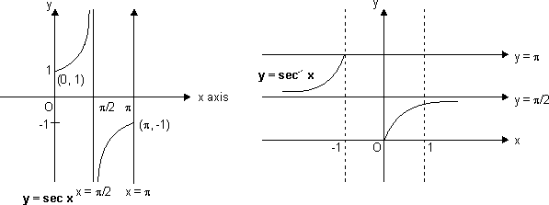
(vi) Graph for y = cosec⁻¹x;
As we know, f: - {0} (- 1, 1) is invertible given by f() = cos.
y = cosec⁻¹x; domain R - (- 1, 1)
Range - {0}>
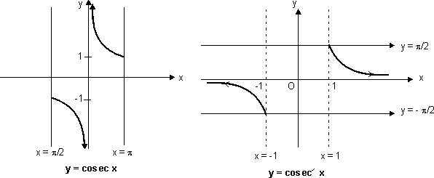
Sketch of y = sin(sin⁻¹x):
Domain x [-1, 1]
and range y = x y [-1, 1]
Sketch y = sin(sin⁻¹x) only
when x [-1, 1] & y = x
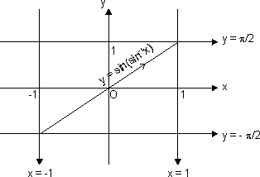
Sketch of curve y = cos(cos⁻¹x):
Domain x [-1, 1]
and range y = x y [-1, 1]
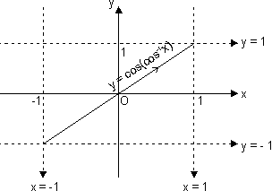
Sketch of curve y = tan(tan⁻¹x):
Domain, x R
Range y = x y r
We should sketch
y = tan(tan⁻¹x) = x v x R
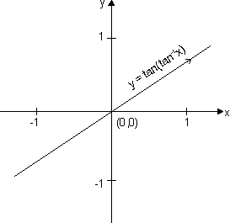
Sketch of curve y = cosec(cosec⁻¹x):
Domain x R - (-1, 1)
Range y = x y R - (-1, 1)
y = cosec(cosec⁻¹x) = x only
when x (-, -1) (1, )
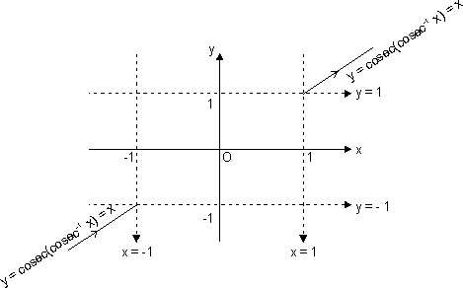

Functions:
Sketch of curve y = sec(sec⁻¹x):
Domain R - (-1, 1)
& range y = x y R - (-1, 1)
y = sec(sec⁻¹x) = x, only when x (-, -1) (1, )
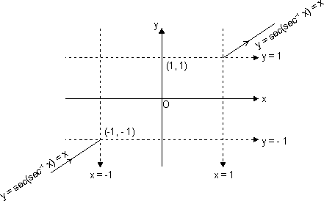
Sketch of y = cot(cot⁻¹x):
Domain R - (-1, 1)
& range y = x y = R
We should sketch
y = cot(cot⁻¹x) = x v x R
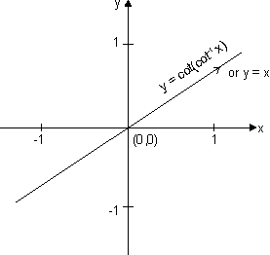
Sketch of y = sin⁻¹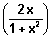:
Domain [-1, 1] v x R
& range y
b/c y = sin⁻¹
y
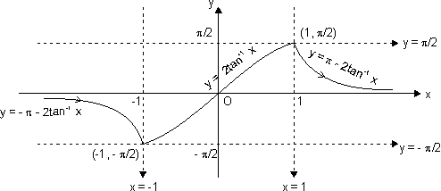
Dumb Question: How domain is [-1, 1] v x R ?
Ans: 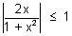 i.e. 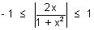
2|x| 1 + x² |x|² - 2|x| + 1 0
(|x| - 1)² 0
x R
Let x = tan
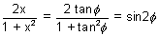
y = sin⁻¹(sin2) = 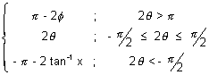
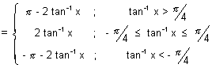
This curve has sharp edge at x = ± 1
So, not differentiable at x = ± 1
Dumb Question: How does y = - 2 for 2 >
Ans: Since our y . So, if 2 > to make it we substract it from - 2 because sin( - 2) = sin2
Sketch of y = cos⁻¹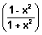
For domain
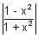1 |1 - x²| 1 + x²
Which is true for all n; as 1 + x² > 1 - x² x R
domain [-1, 1]
For range
y =cos⁻¹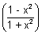
y (0, )
Let x = tan
y = cos⁻¹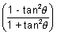 = cos⁻¹(cos2)
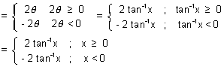
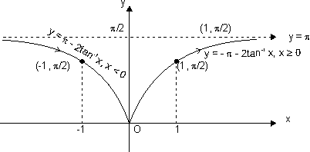
Dumb Question: How cos⁻¹(cos2) = - 2 tan⁻¹x when x < 0 or < 0
Ans: Range of y [0, ]. So, when < 0 or x < 0
Then we have to make it b/w [0, ]
So, cos⁻¹(cos2) = - 2 when < 0
because
cos(- 2) = cos2
This curve has sharp edge at x = 0. So, not differentiable at x = 0.
Sketch of y = tan⁻¹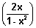
For domain
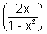R except 1 - x² = 0
i.e. x ± 1
or x R - {1, -1}
domain R
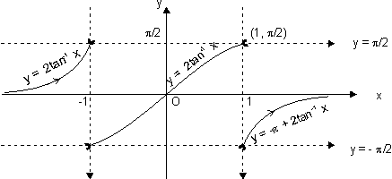
Range y = tan⁻¹
as y = tan⁻¹ y
Let x = tan
y = tan⁻¹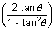 = tan⁻¹(tan2) = 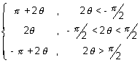
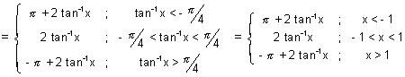
Dumb Question: Why y = tan⁻¹(tan2) = - + 2 tan⁻¹x, for > ?
Ans: Range of y & when > So, 2 > .
To make it within range we substract So, it comes under range.
Because of tan(- + 2) = tan2, this can be done.
This curve is neither continous nor differentiable at x = {-1, 1}
Sketch of curve y = tan⁻¹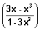
For domain,
y = tan⁻¹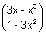
x r except 1 - 3x² = 0 x ±
x R - {± }
domain R
For range
y = tan⁻¹
y
Let x = tan
y = tan⁻¹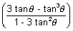 = tan⁻¹(tan3) = 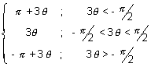
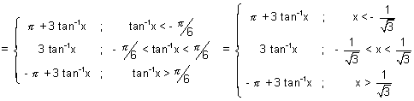
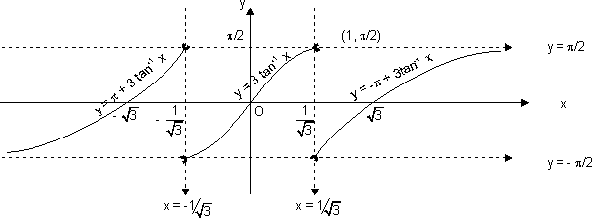
Dumb Question: Why tan⁻¹(tan3) = + 3 if < - ?
Ans: Range of tan⁻¹(tan3) is but if < - So, 3 < - So, to make it within given range. We add to it.
and in IIIrd quadrant.
tan( + 3) = tan3
So, this is done.
This curve is neither cont. nor differentiable at x = ± .
Sketch of y = sin⁻¹(3x - 4x³):
For domain
y = sin⁻¹(3x - 4x³)
x [-1, 1]
For range
y = sin⁻¹(3x - 4x³) y
Let x = sin
y = sin⁻¹(sin3) = 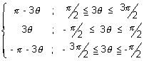
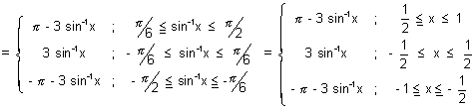
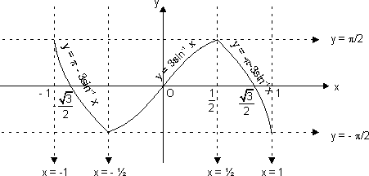
This curve has sharp edge at x = ± 1/2 so, not differentiable at x = ± 1/2.
ketch of curve y = cos⁻¹(4x³ - 3x)
Domain [-1, 1] range [0, ]
Let x = cos
y = cos⁻¹(cos3) = 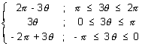
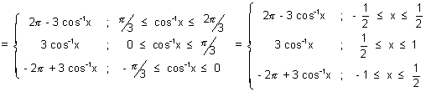
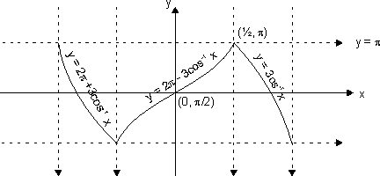
This curve has sharp edge at x = ± 1/2. So, not differentiable at x = ± 1/2.
Dumb Question: Why y = cos⁻¹(cos3) = 2 - 3 if .
Ans: Range of y [0, ) if 3 2. So, it s out of range so, it make it within range, we subtract it from 2
and cos(2 - 3) = cos3
Odd and Even functions: A function is said to be an odd function if, f(-x) = - f(x) for all x.
Graph of odd function is symmetrical in opposite quadrants. eg.
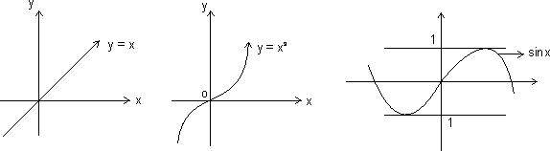
Even function: A function f(x) is said to be an even of f(-x) = f(x) for all x.
Graph is symmetrical about y-axis.
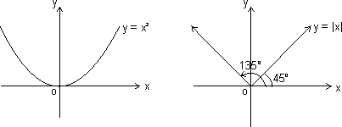
Properties:
(i) Product of two odd functions or two even functions is an even function.
(ii) Product of odd and even function is an odd function.
(iii) Every function y = f(x) can be expressed as sum of an even and odd function.
Illustration: IF f is an even function, find real values of x satisfying eq. f(x) = f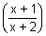
Ans: Since f(x) is even function
f(x) = f(-x)
Thus, x = or - x =
x² + x - 1 = 0 or - x² - 3x - 1 = 0
x = 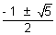 or x = 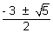
x = 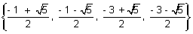
Periodic Function: A function f(x) is said to be periodic function if, there exists a +ve real no. such that,
f(x + T) = f(x), v x R
Then, f(x) is periodic with period T, where T is least +ve value.
eg. sin x is priodic with period 2.
Illustration: Prove that f(x) = x - [x] is periodic function. Also find its period.
Ans: Let T > 0,
Then, f(x + T) = f(x), v x R
(x + T) - [x + T] = x - [x] v x R
[x + T] - [x] = T v x R
T = 1, 2, 3, 4, .............. {Since subtraction of two integer}
Smallest value of T satisfying
f(x + T) = f(x) is 1
So, period with period 1.
Properties of periodic function:
(i) If f(x) is periodic with period T, then,
c.f(x), f(x + c) & f(x) ± c is periodic with period T.
eg. if sin x has period 2. Then f(x) = 5 sinx + 4 is also periodic with period 2.
(ii) If f(x) is periodic with period T, then, kf(cx + d) has period
f(x) = 7 sin2x - 12 has period = as sinx is periodic with period 2.
(iii) If f₁(x), f₂(x) are periodic functions with periods T₁, T₂ respectively then; h(x) = af₁(x) ± bf₂(x) has period as
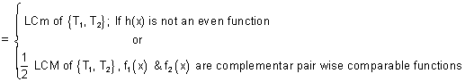
LCM of 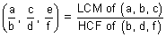
Note: LCM of rational and irrational is not possible. eg. 2 is irrational & 1 is rational.
Composite Function:
Let two function,
f : x Y₁ and g : Y₁ Y
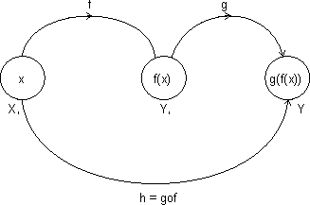
Let another function h : X Y
Such that
h(x) = g(f(x)) = (gof)(x)
domain (gof) = {x : x domain (f), f(x) domain (a)}
domain fog(x) = {x : x domain (g), g(x) domain f}
gof exist iff range of f domain of g
fog exist iff range of g domain of f.
Properties of composite function:
(i) f is even, g is even fog is even function.
(ii) f is odd, g is odd fog is odd function.
(iii) f is even, g is odd fog is even function.
(iv) f is odd, g is even fog is even function.
Illustration: Let g(x) = 1 + x - [x] & f(x) = 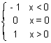. Find fog(x).
Ans: g(x) = 1 + x - [x] = 1 {x}
g(x) is greater than J.
So, f(g(x)) = 1. since f(x) = 1 for all x > 0
f(g(x)) = 1 for all x R.
Mapping of function: A function exists only if,” to every element in domain there exists unique image in co domain.
f : A B
One - One Mapping (Injective): A function f: A B is said to bwe one-one mapping if different elements of A have different images in B. no two elements of set A can have same 'f' image
eg.
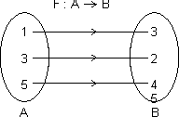
f(x) is one-one
Methods to find one-one mapping:
(1) Graphically: A fun. is one-one if no line 11 to x-axis meets graph of function at more than one point.
By Calculus: If f(x) is function and if f'(x) 0 v x domain i.e. increasing or f'(x) 0 v x domain i.e. decreasing, then one-one.
No. of one-one Mapping: If A & B are finite sets having m & h elements, then, no. of one-one function from A to B
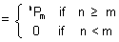
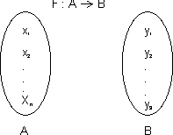
Dumb Question: How No. of one-one mapping is ^{n}P_{m} if n m.
Ans: x₁ can take n images
x₂ can take (n - 1) images
.....................................
.....................................
.....................................
.....................................
x_{m} can take (n - m + 1) images
No. of mapping = n(n - 1)(n - 2) ............... (n - m + 1) = ^{n}P_{m}
Many one Mapping: A mapping f : A B is many one if two or more elements of set A have the same image in B.
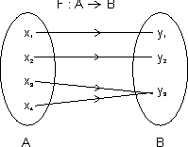
i.e. f(x³) = f(x₄) = y₃
Onto Function (Surjective): If function f : A B is such that each element of B is the 'f' image of at least one element in A.
i.e. range of f = co domain f(A) = B
Into Function: A function of f : A B is into if there exists an element in B having no pre image in A.
No. of one-one onto mapping (bijection): If A & B are finite sets & f : A B is a bijection.
Then A & B have same no. of elements.
Total no. of bijection A B = n !
Dumb Question: How total no. of bijection A B = n ! ?
Ans: x₁ can take n images
x₂ can take (n - 1) images
x₃ can take (n - 2) images
.....................................
.....................................
.....................................
x_{m} can take 1 images
No. of mapping = n(n - 1)(n - 2) ............... 1 = n !
Functions:
Illustration: Find no. of surjection from A B
A = {1, 2, 3, 4} & B = {a, b}
Ans:
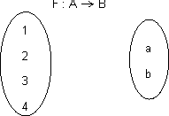
1 2 images
2 2 images
3 2 images
4 2 images
Total no. of function = 2 x 2 x 2 x 2 = 2⁴
But there are two function f(x) = a for all x A & g(x) = b for all x A are not surjective.
Total no. of surjection from A to B = 2⁴ - 2 = 14
Inverse function: Let f : A B be one-one & onto function then there exists a unique function.
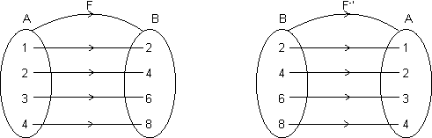
g : B A such that f(x) = y g(y) = x, v x A & y B
Then g is c/d inverse of F.
So, g = f⁻¹ : B A = {(f(x), x) | (x, f(x) f}
Domain of f = {1, 2, 3, 4} = range of f⁻¹
Range of f = {2, 4, 6, 8} = domain of f⁻¹.
Illustration: If f(x) = 3x - 5, then find f⁻¹(x).
Ans: f(x) = 3x - 5 which linear function so bijective.
Let f(x) = y Y = 3x - 5
x = 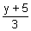 f⁻¹(y) =
f⁻¹(x) = 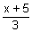
Note: (1) Graph of y = f(x) and y = f⁻¹(x) are mirror images to each other.
(2) If f : A B & g : B C are two bijections, then gof : A C is bijection & (gof)⁻¹ = (f⁻¹og⁻¹).
(3) If fog = gof then either f⁻¹ = g or g⁻¹ = f and (fog)(x) = (gof)(x) = (x)
Easy Type
Q.1. Find domain of f(x) = log₁₀log₁₀(1 + x³)
Ans: Let log₁₀(1 + x³) = y
f(x) = log₁₀y y > 0
log₁₀(1 + x³) > 0 (1 + x³) > 10⁰
x³ > 0 x (0, )
Q.2. Find domain of y =
Ans: Let log₂x = z
z is defined if x > 0 .......................................... (i)
and - 1 z 1 or - 1 log₂x 1
1/2 x 2 ................................................. (ii)
But y is defined if
sin⁻¹z 0 or sin⁻¹log₂(x) 0 ..................... (iii)
log₂x 0 x 2⁰ x 1 .................. (iv)
From (i), (ii) & (iv)
1 x 2
domain x [1, 2]
Q.3. Find values of 'a' for which f(x) = tan⁻¹(x² - 18x + 9) > 0 for x R.
Ans: f(x) > 0 v x R
x² - 18x + a > 0 v x R
ax² + bx + c > 0 if D < 0 & a > 0
D = (18)² - 49 < 0 a > 81
a (81, )
Q.4. f(x) = 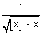 find domain of f9x).
Ans: f(x) = exists if
[x] - x > 0 [x] > x
But by definition of greatest integer function
[x] x as x = [x] + {x}
So, it is not possible that [x] > x
domain f(x) =
Q.5. Solve 4{x} = x + [x]
Ans: x = [x] + {x}
4{x} = [x] + {x} + [x] {x} = 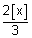
But 0 {x} < 1
0 < 1 0 [x] < 3/2
[x] = 0 or 1
If [x] = 1, then {x} = 2/3
Thus, x = [x] + {x} = 1 + 2/3 = 5/3
If [x] = 0, {x} = 0
x = 0
Solutions x {0, 5/3}
Q.6. Find range for y = 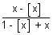.
Ans: y = = 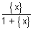
Domain R
y = {x} = 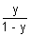
Since 0 {x} < 1 0 < 1 0 y < 1/2
range = (0, 1/2)
Q.7. Let f(x) be periodic & k bca +ve real no. such that f(x + k) + f(x) = 0 v x R. Prove that f(x) f(x) is periodic with period 2k.
Ans: f(x + k) + f(x) = 0 v x R
f(x + k) = - f(x) v x R ................................................... (i)
put x = x + k
f(x + 2k) = -f(x + k) v x R
from (i)
f(x + 2k) = f(x), v x R
f(x) is peruiodic with period 2k.
Q.8. Find period of f(x) = tan3x + sin
Ans: Period for tan 3x is 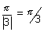
Period for sin is |2 x = 6
LCM of sin⁻¹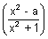 <
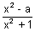< 1 1 - 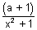< 1, v x R
- - < 0
a + 1 > 0
a (-1, )
Q.10. If f : R R f(x) = x² + 1, then find value of f⁻¹(17).
Ans: f(x) = x² + 1
f⁻¹(17) f(x) = 17
x² + 1 = 17 x = ±4
x = {4, -4}
Medium Type
Q.1. Find domain of function. f(x) = 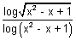
Ans: log(x² - x + 1) is defined when
x² - x + 1 > 0 & x² - x + 1 1
x R and x 0, 1
x R - {0, 1} ..................................... (i)
[Dumb Question: How x² - x + 1 > 0 v x R & why x² - x + 1 1 ?
Ans: ax² + bx + c > 0 v x R if a > 0 & D < 0
For x² - x + 1, a = 1 > 0 & D = 1 - 4 = - 3 < 0
So, x² - x + 1 > 0 for all x R
& If x² - x + 1 = 1 then logx² - x + 1 = 0
& 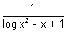= which is not desired.]
Again log(sin⁻¹⁾ exists when x² + x + 1 > 0 & x² + x + 1 1
i.e. 0 < x² + x + 1 1
x² + x 0 x [-1, 0] .............................. (ii)
From (i) & (ii)
x [-1, 0)
Q.2. Find domain of f(x) = 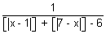 where {} is greatest integer function.
Ans: f(x) is defined when
[|x - 1|] + [|7 - x|] - 6 0
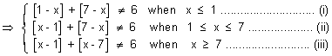
Taking (i)
[1 - x] + [7 - x] 6 1 + [-x] + 7 + [-x] 6
2[-x] - 2 [-x] - 1
x (0, 1] ................................... (1)
From (ii)
[x - 1] + [7 - x] 6 [x] - 1 + 7 + [-x] 6
[x] + [-x] 0 x Integer
x {1, 1, 3, 4, 5, 6, 7} ................. (2)
From (iii)
x [7, 8) ..................................... (3)
From (1), (2) & (3)
Domain f(x) R - {(0, 1] {1, 2, 3, 4, 5, 6, 7} [7, 8)}
Q.3. f(x, y) is periodic function satisfying condition f(x, y) = f((2x + 2y),(2y - 2x)) v x,y R. Now g(x) = f(2^{x}, 0) then prove that g(x) is periodic function, find its period.
Ans: f(x, y) = f(2x + 2y, 2y - 2x) ....................................... (i)
Put x = 2x + 2y & y = 2y - 2x
f(2x + 2y, 2y - 2x) = f(2(2x + 2y) + 2(2y - 2x), 2(2y - 2x) - 2(2x + 2y)) [By (i)]
f(x, y) = f(2x + 2y, 2y - 2x) = f(8y, - 8x)
f(x, y) = f(8y, - 8x) ..................................................... (ii)
f(8y, - 8x) = f{8(- 8x), - 8(8y)} [By (ii)]
f(x, y) = f(2x + 2y, 2y - 2x) = f(8y, - 8x) = f(- 64x, - 64y)
f(x, y) = f(- 64x, - 64y) ............................................... (iii)
f(- 64x, - 64y) = f(64 x 64 x, 64 x 64y) = f(2¹²x, 2¹²y) [By (iii)]
f(x, y) = f(2¹²x, 2¹²y)
f(2^{x}, 0) = f(2¹².2^{x}, 0) = f(2^{12 + x}, 0)
g(x, 0) = f(2^{x}, 0) = f(2^{12 + x}, 0)
g(x, 0) = g(x + 12, 0)
g(x) is periodic with period
Q.4. Let f(x) = 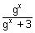. Show that f(x) + f(1 - x) = 1 & hence, evaluate
Ans: f(x) = ................................................. (i)
and f(1 - x) = 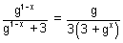.............................. (ii)
Adding (i) & (ii), we get
f(x) + f(1 - x) = + 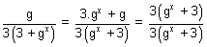
f(x) + f(1 - x) = 1 ............................................. (iii)
Now, putting x = 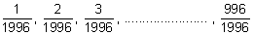in (iii).
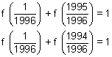
........................
........................
........................
........................
........................
........................
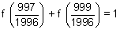
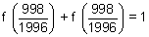 or 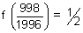
Adding all.
[Dumb Question: For what is added ?
Ans: For 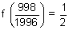]
= 997 + = 997.5
Q.5. Let g(x) be inverse of f(x) and f'(x) = 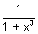. Then find g'(x) in terms of g(x).
Ans: Since g(x) is inverse of f(x)
(gof)(x) = x
g{f(x)} = x
g'{f(x)} f'(x) = 1
g'{f(x)} = 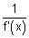= 1 + x³
g'{f(g(x))} = 1 + (g(x))³
g'(x) = 1 + (g(x))³
Dumb Question: How f(g(x)) = x ?
Ans: Since g(x) is inverse of f(x)
f(x) is also inverse of g(x)
By inverse property
f(g(x)) = x

Hard Type
Q1. Prove that a² + b² + c² + 2abc < 2 where a, b, c, are sides of ABC such that a + b + c = 2
Ans: a + b + c = 2
1 - a + 1 - b + 1 - c = 1
x + y + z = 1 where x = 1 - a, y = 1 - b, z = 1 - c
Sine in
Sum of two sides > third side
a + b > c 0 < c < 1
Similarly 0 < a, b < 1
hence 0 < x, y, z < 1
Now,
a² + b² + c² + 2abc = (1 - x)² + (1 - y)² + (1 - z)² + 2(1 - x)(1 - y)(1 - z)
= 3 - 2(x + y + z) + x² + y² + z² + 2{1 - (x + y + z) + (xy + yz + zx) - xyz}
= 1 + x² + y² + z² - 2xyz + 2(xy + yz + zx)
= 1 + (x + y + z)² - 2xyz
= 2 - 2xyz < 2 as 0 < x, y, z < 1
a² + b² + c² + 2abc < 2
Dumb Question: How 0 < c < 1 ?
Ans: Since g_{n} ,
Sum of two sides > third side
a + b > c ............................................. (i)
or a + b + c > 2c
2 > 2c c < 1 ..................................... (ii)
Since c is side of
c > 0 ............................................... (iii)
From (ii) & (iii)
0 < c < 1
Q.2. A function R R is f(x) = 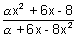. Find integral value of for which f is onto.
Ans: Since f : R R is onto mapping
Range = codomain = R
assumes all real values of x
Let y =
x²( + 8y) + 6x(1 - y) - (8 - y) = 0 v y R
D 0
36(1 - y)² + 4( + 8y)(8 + y) 0
[y²(8 + 9) + y(² + 46) + (8 + 9) 0
ax² + bx + c 0 v x R if a > 0 & D 0
(² + 46)² - 4(8 + 9)(8 + 9) 0 & (8 + 9) > 0
(² + 46)²) - [2(8 + 9)]² 0 & > -
(² + 46 - 16 - 18)(² + 46 + 16 + 18) 0 & > -
( - 14)( - 2)( + 8)² 0 and > -
[2, 14] {-8} and > -
[2, 14]
Q.3. Solve the eq. [x]{x} = x
Ans: x = [x] + {x} .................................. (i)
[x]{x} = [x] + {x} {x} = 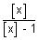............................. (ii)
[x] 1 in eq. (ii)
But if [x] = 1, then
{x} = x which is donje only when,
x [0, 1) ................................................. (iii)
& [x] = 1 [1, 2) ................................. (iv)
From (iii) & (iv) no value of x,
when [x] = 1
As we know
{x} [0, 1)
0 < 1
< 1 & 0
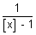< 0 & {[x] 0 or [x] > 1}
[x] < 1 & {[x] 0 or [x] > 1}
[x] 0
x = [x] + {x} = [x] +
x = 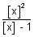, where x takes values less than 1.
x = , where x < 1
x = , where [x] is any non positive integer.
Q4. Sketch y = (x - 1)(x - 2)
Ans: y = (x - 1)(x - 2)
(i) put y = 0 x = 1, 2
(ii) y = x² - 3x + 2
= 2x - 3 &
as > 0
minimaq at x = 3/2.
(iii) Increases when x > 3/2 & decreases when x < 3/2.
y = x² - 3x + 2
when x = 3/2
y = 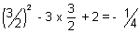
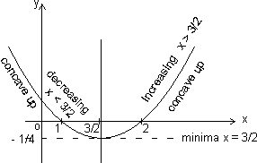
Q5. Sketch curve y = (x - 1)(x - 2)(x - 3)
Ans: y = (x - 1)(x - 2)(x - 3)
(i) Put y = 0 x = 1, 2, 3
(ii) y = x³ - 6x² + 11x - 6
= 3x² - 12x + 11 & = 6x - 12
when = 0 x = 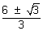
Maxima when x = 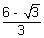 as = - 2
Minima when x = 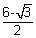 as = 2
(iii) = 3x² - 12x + 11
= 3(x - )(x - )
> 0 or Increases when
x < or x >
Decreases when < 0
or < x <
(iv) Concave upwards when x > 2 & concave down when x < 2.
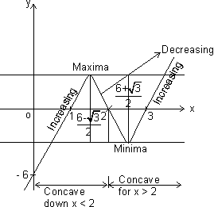
x = 2 is point where concavity of curve changes.
Key Words:
* Function.
* Domain.
* Co domain.
* Range.
* Identity Function.
* Constant Function.
* Logarithmic Function.
* Modulus Function.
* Signum Function.
* Greatest Integer Function.
* Fractional Part Function.
* Odd & Even Function.
* Periodic Function.
* Composite Function.
* Mapping.
* Bijective.
* Surjective.
* Injective.
* Inverse of Function.

